# Inheritance Lab

**15 Points**

1. Consider using the following Card class that represents a general type of membership card.

public class Card{

private String name;

public Card(){

name = "";

}

public Card(String n) {

name = n;

}

public String getName(){

return name;

}

public boolean isExpired(){

return false;

}

public String format(){

return "Card holder: " + name;

}

}

Use the Card class as a superclass to implement this hierarchy of related classes:

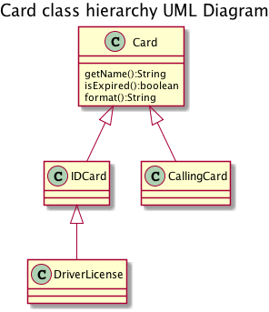

Write declarations for each of the subclasses. For each subclass, supply private instance variables as listed in the table shown above. Implement constructors for each of the three subclasses. Each constructor should call the superclass constructor to set the name. Here is one example:

|  |  |
| --- | --- |
| Class | Data |
| IDCard | ID number |
| DebitCard | Card number, PIN |
| DriverLicense | Expiration year |

public IDCard(String n, String id){

super(n);

idNumber = id;

}

Replace the implementation of the format method for the three subclasses. The methods should produce a formatted description of the card details. The subclass methods should call the superclass format method to get the formatted name of the cardholder.

Upload the files from this assignment - **IDCard.java**, **DebitCard.java,** and **DriverLicense.java** .